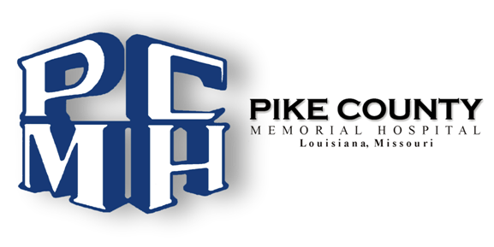

Financial Assistance Policy / Plain Language Summary

Pike County Memorial Hospital will provide discounted care for emergent and/or medically necessary care for individuals who qualify for assistance under our Financial Assistance policy. Certain exclusions may apply, including, for example, elective services, balances covered by other sources, and failure to assist in providing complete and accurate information.

Eligibility
All guarantors, with family income between 100% and 200% of the federal poverty standard, adjusted for family size, generally receive a discount ranging from 25% to 65% discount from charges related to appropriate hospital-based medical services. In the case of emergency or other medically necessary care covered under the FAP, patients eligible under a hospital facility’s FAP may not be charged more than the amounts generally billed to individuals who have insurance covering such care. All charges are usual and customary.

How to Obtain Copies of the Financial Assistance Policy and Financial Assistance Application
The complete Financial Assistance Policy (“FAP”), along with an application for financial assistance, can be found at www.pcmh-mo.org. Paper copies are also available in the patient registration area and the Business Office of PCMH and will be mailed free-of-charge to a patient upon request:

Requests by phone: 573-754-5531 ext. 116
Requests by mail:
Pike County Memorial Hospital
2305 Georgia Street
Louisiana, MO 63353

How to apply
Individuals may apply for financial assistance under the facility’s FAP by mailing a completed application, along with proof of household income, to the above address or by bringing the application and proof of household income to the Business Office located on the 2nd floor of the hospital. Patients may also call or visit the above location to receive assistance with the application process.

